Faculty of Computing

CS 212: Object Oriented Programming

Class: BESE-16B

Lab07: Inheritance

Date: 2nd March, 2026

Time: 9:45 am- 12:45 pm

Instructor: Dr. Muhammad Daud Abdullah Asif

Lab 7: Inheritance
Introduction
This lab is about Inheritance and making inherited classes.

Objectives
The learning objective of this lab is to understand and practice the concept of inheritance, a very powerful feature of OOP which helps in code reusability.

Tools/Software Requirement
Net Beans.

Description
Activity #1.
What is the output of running the class ActivityOne? Explain the output.
Hint. Remember only super-class data members (instance variables and instance methods) are inherited by the sub-class, and these does not include constructors.
class A
{
public A()
{
System.out.println( "A's no-arg constructor is invoked");
}
}

class B extends A {}

public class ActivityOne
{
public static void main( String[] args)
{
B b = new B();
}
}

Activity #2.
The Java program compiles correctly. Show its output, and explain what is happening when an object of Class B is created?
class A
{
public A()
{
System.out.println( "A's constructor is invoked");
}
}

class B extends A
{
public B(int t)
{
System.out.println( "B's constructor is invoked");
}
}

public class ActivityTwo
{
public static void main( String[] args)
{
B b = new B(3);
}
}

Activity #3.
The program fails to compile. Identify the problem and propose a correction? Also explain the reason.
Hint. If any constructor does not explicitly call a super or this constructor as its first statement, a call to super() is automatically added.
class A
{
public A( int x) {}
}

class B extends A
{
public B() {}
}

public class ActivityThree
{
public static void main( String[] args)
{
B b = new B();
}
}

Activity #4.
Identify and correct the problems in the following program.
class Circle
{
private double radius;

public Circle( double radius)
{
radius = radius;
}

public double getRadius()
{
return radius;
}

public double getArea()
{
return radius * radius * Math.PI;
}
}

class B extends Circle
{
private double length;

B( double radius, double length)
{
Circle( radius);
length = length;
}

/** Override getArea() */
public double getArea()
{
return getArea() * length;
}
}

public class ActivityFour
{
public static void main( String[] args)
{
B b = new B( 5, 10);
System.out.println( "Area = " + b.getArea());
}
}

Lab Tasks
Task #1:
The following UML class diagram illustrates an inheritance relationship, wherein the classes Circle and Rectangle have been extended from the class GeometricObject.
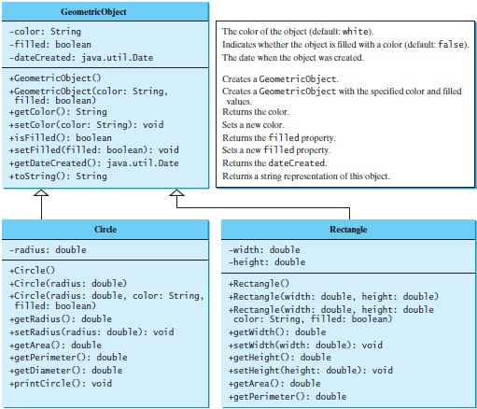
You’re required to implement the classes GeometricObject and Rectangle.
The Rectangle class contains:
- Two double data fields named width and height that specify the width and height of the rectangle. The default values are 1.0 for both width and height.
- A no-arg constructor that creates a default rectangle.
- A constructor that creates a rectangle with the specified width and height.
- A method named getArea() that returns the area of this rectangle.
- A method named getPerimeter() that returns the perimeter.
- A method named toString() that returns a string description for the rectangle.
The toString() method is implemented as follows:
return "Rectangle: width = " + width + " height = " + height;
Write a test program that prompts the user to enter width and height of the rectangle, a color, and a Boolean value to indicate whether the rectangle is filled. The program should create a Rectangle object and set the color and filled properties using the input. The program should display the area, perimeter, color, and true or false to indicate whether it is filled or not.

Deliverables
Submit a Word document that includes the source code and a screenshot of the program’s output.

